**Section -1: Sampling**

For each of the signals, determine the appropriate bandwidth and the Nyquist sampling rate

* + Nyquist Rate = 1.36 Hz
 $x\left(t\right)=\frac{\sin^{2}\left(t\right)}{t^{2}}$

 + Nyquist Rate = 0.68 Hz
 $x\left(t\right)= \begin{matrix}\cos\left(πt\right) \left|t\right|<1 \\ 0 Otherwise\end{matrix}$

 + Nyquist Rate = 1.54 Hz

**MATLAB CODE**



function output = Integrate(y, x)

output = 0;

for x_i = 1: length(x) - 1

output = output + (y(x_i) + y(x_i + 1))*(x(x_i + 1) - x(x_i)) / 2;

end

end

**MATLAB CODE**



function output = FT(signal, time, W)

output = zeros(size(W));

for iw = 1:length(W)

w = W(iw);

output(iw) = Integrate(signal.*exp(-1i*w*time),time);

end

end

**MATLAB CODE**



close all; clear;

t = 0:0.01:2;

x = zeros(size(t));

x(t >= 0 & t <= 2) = (t(t >= 0 & t <= 2) -1).^2;

L = length(t);

f = -4:0.01:4;

X = FT(x, t, 2*pi*f);

mx = abs(max(X)/sqrt(2));

% mx1 = min(find(X(f > 0) < mx)) + length(find(X(f <= 0)));

mx1 = max(find(X(f > 0) >= mx)) + length(find(X(f <= 0))) + 1;

mx2 = min(find(X(f <= 0) >= mx)) - 1;

% Plotting the FFT

figure;

plot(f,X);

hold on;

stem([f(mx1), f(mx2)], [X(mx1), X(mx2)], 'r', 'filled');

title('Fourier Transform of Signal'); xlabel('f (Hz)'); ylabel('X(W)');

grid;

mTxt = sprintf(' Wm = %.2f Hz',f(mx1)); text(f(mx1), X(mx1), mTxt);

mTxt = sprintf(' Wm = %.2f Hz',f(mx2)); text(f(mx2), X(mx2), mTxt, 'HorizontalAlignment', 'right');

Nr = 2*(f(mx1)); sprintf('Nyquist Rate is %.2f Hz.', Nr)

% SAMPLING SIGNAL

s_rate = round(((1/Nr)/(t(2)-t(1))))*(t(2)-t(1));

sample_time = [fliplr([-s_rate + 1:-s_rate:t(1)]), 1 : s_rate : t(end)];

sample_signal = zeros(size(t));

it = 1;

for tt = sample_time

sample_signal(abs(t - tt) < (t(2)-t(1))/2) = x(abs(t - tt) < (t(2)-t(1))/2);

x2(it) = x(abs(t - tt) < (t(2)-t(1))/2);

it = it + 1;

end

% PLOTTING THE SAMPLED SIGNAL

figure;

plot(t,x);

hold on;

stem(sample_time, x2, 'ro', 'LineWidth', 3);

title('Continous Signal v/s Sampled Signal'); xlabel('time'); ylabel('x(t)');

grid; axis equal;

legend('Continous','Sampled');

% FOURIER TRANSFORM OF SAMPLED SIGNAL

X = FT(sample_signal, t, 2*pi*f);

X = X/L;

L = length(X);

X(1:end) = 2*X(1:end);

f2 = linspace(0,L,round(L))/L/(t(2) - t(1));

figure;

plot(f2,X);

title('Fourier Transform of Sampled Signal'); xlabel('f (Hz)'); ylabel('X(W)');

grid;

% Recovering Signal

Ts = sample_time(2)- sample_time(1);

Tr = t(2) - t(1);

xr = zeros(size(t));

xr2 = zeros(size(t));

for it = 1:length(t)

xr2(it) = xr2(it) + x2*sinc((t(it) - sample_time)/Ts)';

for ip = 1:length(sample_time)

xr(it) = xr(it) + x2(ip) * sinc(((it-1)*Tr - (ip-1)*Ts)/Ts);

end

end

% PLOTTING THE RECOVERED SIGNAL

figure;

plot(t,x, 'r');

hold on;

plot(t, xr2, 'k');

title('Original Signal v/s Signal Recreated from Sample'); xlabel('time'); ylabel('x(t)');

grid; axis equal;

legend('Original','Reconstructed');

**OUTPUT**

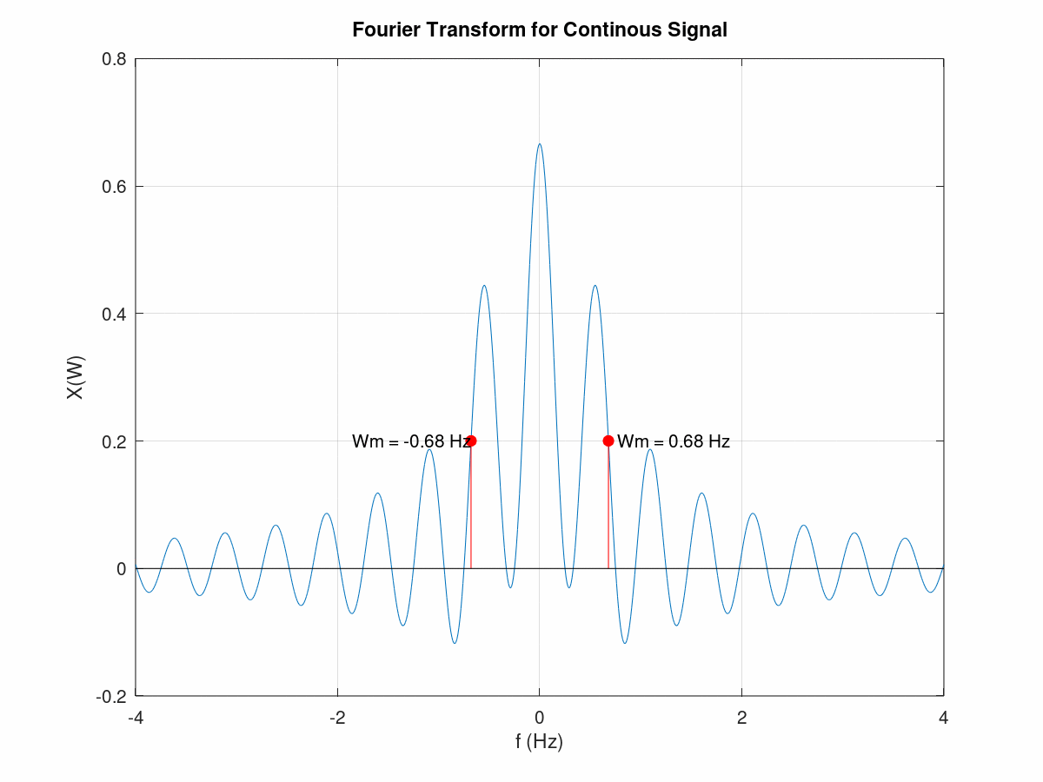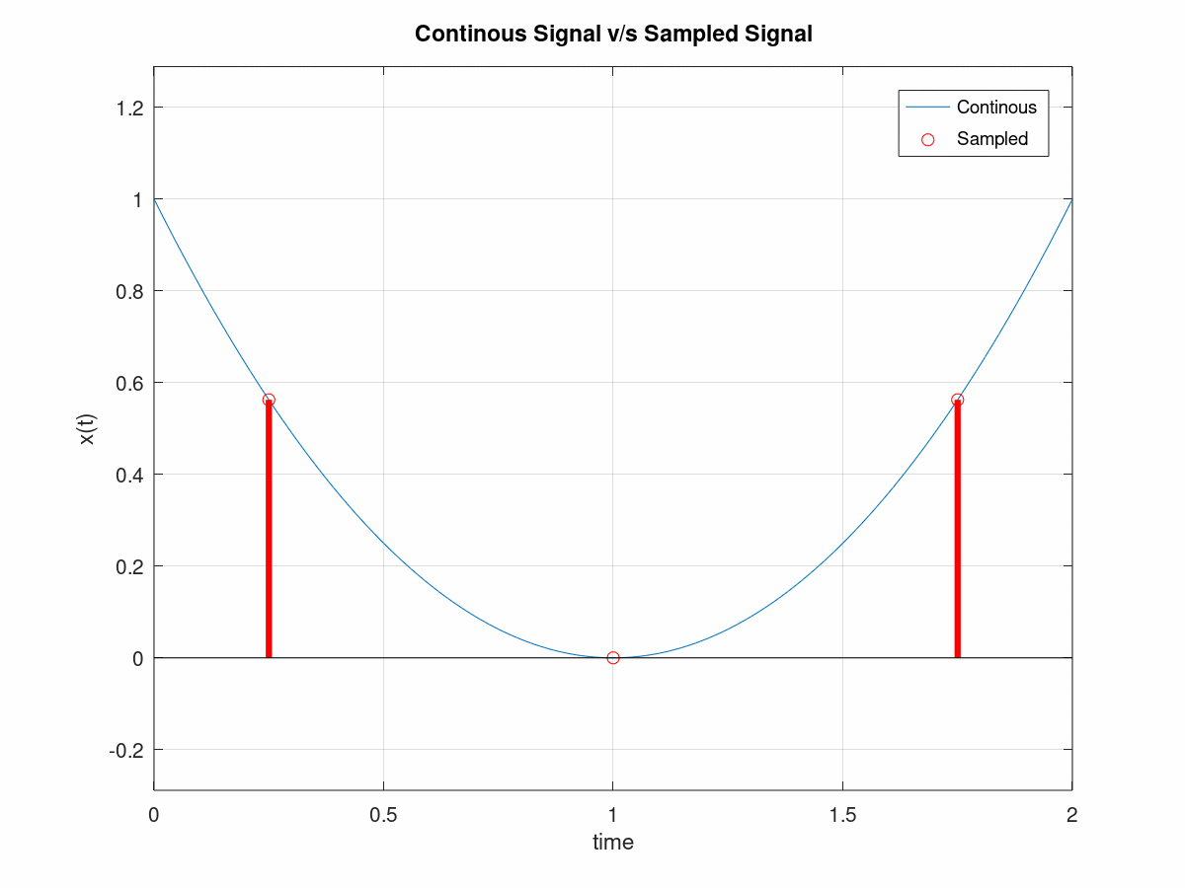

**OUTPUT ( EXTRA WORK / NO GRADING )=-**

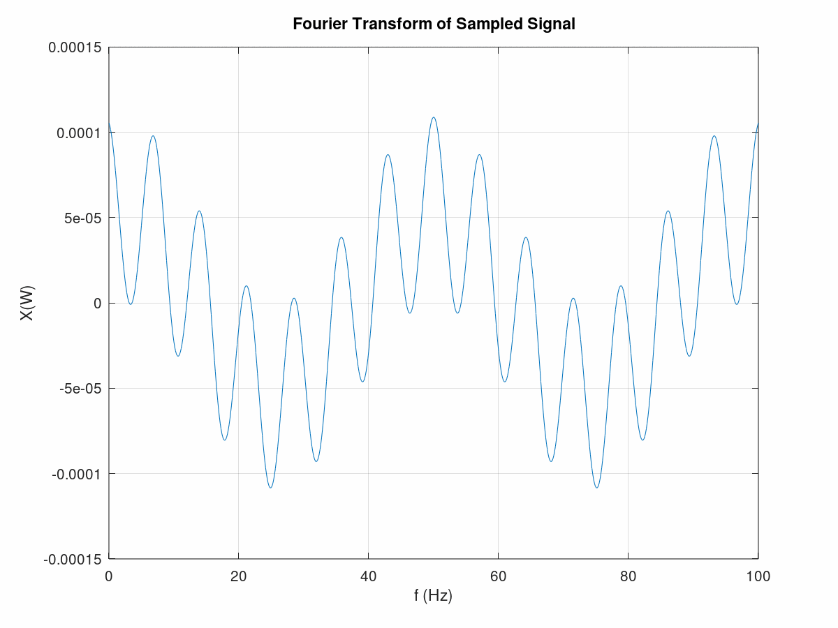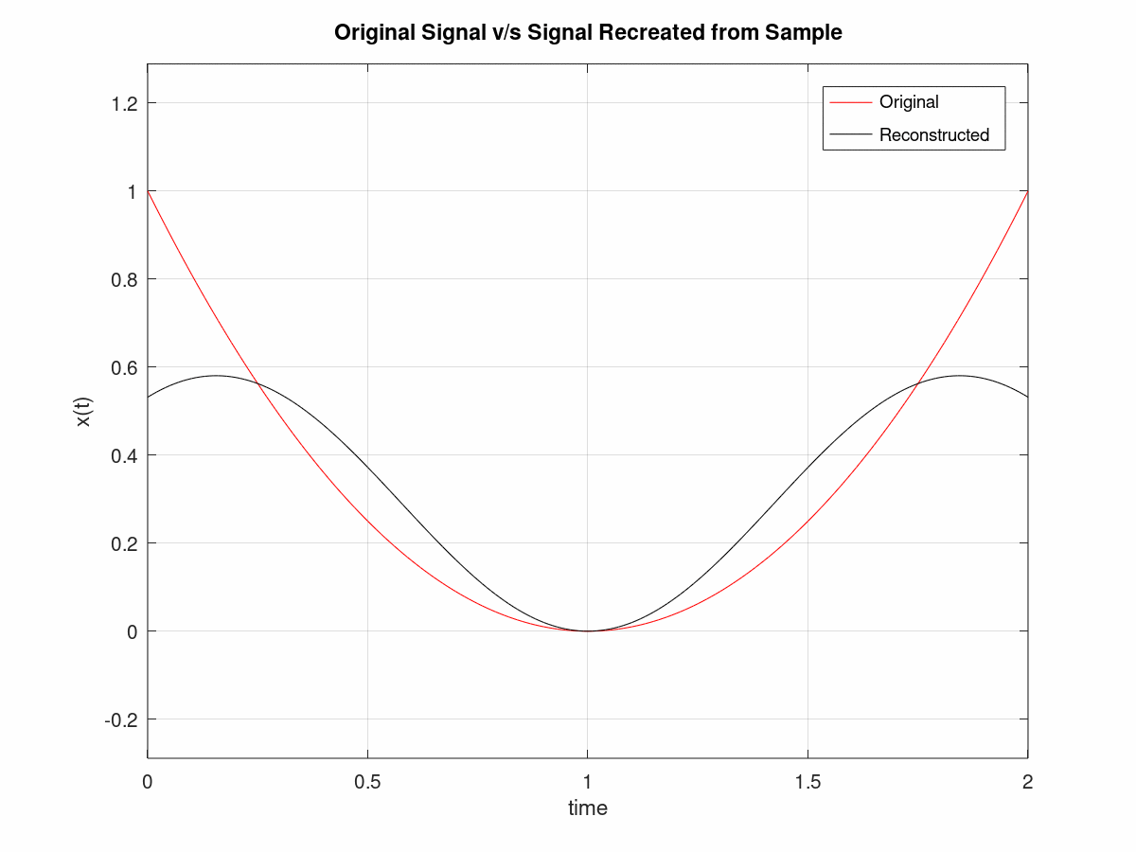

**MATLAB CODE**



close all; clear;

t = -2*pi:0.01:2*pi;

x = zeros(size(t));

x = sinc(t/pi).^2;

L = length(t);

f = -4:0.01:4;

X = FT(x, t, 2*pi*f);

mx = 1e-2;

% Bandlimited signal

mx1 = min(find(X(f > 0) < mx)) + length(find(X(f <= 0))) + 1;

mx2 = max(find(X(f <= 0) < mx)) - 1;

% Plotting the FFT

figure;

plot(f,X);

hold on;

stem([f(mx1), f(mx2)], [X(mx1), X(mx2)], 'r', 'filled');

title('Fourier Transform for Continous Signal'); xlabel('f (Hz)'); ylabel('X(W)');

grid;

mTxt = sprintf(' Wm = %.2f Hz',f(mx1));

text(f(mx1), X(mx1), mTxt);

mTxt = sprintf(' Wm = %.2f Hz',f(mx2));

text(f(mx2), X(mx2), mTxt, 'HorizontalAlignment', 'right');

Nr = 2*(f(mx1));

sprintf('Nyquist Rate is %.2f Hz.', Nr)

% SAMPLING SIGNAL

s_rate = round(((1/Nr)/(t(2)-t(1))))*(t(2)-t(1));

sample_time = [fliplr([-s_rate:-s_rate:t(1)]), 0 : s_rate : t(end)];

sample_signal = zeros(size(t));

it = 1;

for tt = sample_time

sample_signal(abs(t - tt) < (t(2)-t(1))/2) = x(abs(t - tt) < (t(2)-t(1))/2);

x2(it) = x(abs(t - tt) < (t(2)-t(1))/2);

it = it + 1;

end

% PLOTTING THE SAMPLED SIGNAL

figure;

plot(t,x);

hold on;

stem(sample_time, x2, 'ro', 'LineWidth', 3);

title('Continous Signal v/s Sampled Signal'); xlabel('time'); ylabel('x(t)');

grid; axis equal;

legend('Continous','Sampled');

% FOURIER TRANSFORM OF SAMPLED SIGNAL

X = fft(sample_signal);

X = X/L;

L = length(X);

X(1:end) = 2*X(1:end);

f2 = linspace(0,L,round(L))/L/(t(2) - t(1));

figure;

plot(f2,X);

title('Fourier Transform of Sampled Signal'); xlabel('f (Hz)'); ylabel('X(W)');

grid;

% Recovering Signal

Ts = sample_time(2)- sample_time(1);

Tr = t(2) - t(1);

xr = zeros(size(t));

xr2 = zeros(size(t));

for it = 1:length(t)

xr2(it) = xr2(it) + x2*sinc((t(it) - sample_time)/Ts)';

for ip = 1:length(sample_time)

xr(it) = xr(it) + x2(ip) * sinc(((it-1)*Tr - (ip-1)*Ts)/Ts);

end

end

% PLOTTING THE RECOVERED SIGNAL

figure;

plot(t,x, 'r');

hold on;

plot(t, xr2, 'k');

title('Original Signal v/s Signal Recreated from Sample'); xlabel('time'); ylabel('x(t)');

grid; axis equal;

legend('Original','Reconstructed');

**OUTPUT**

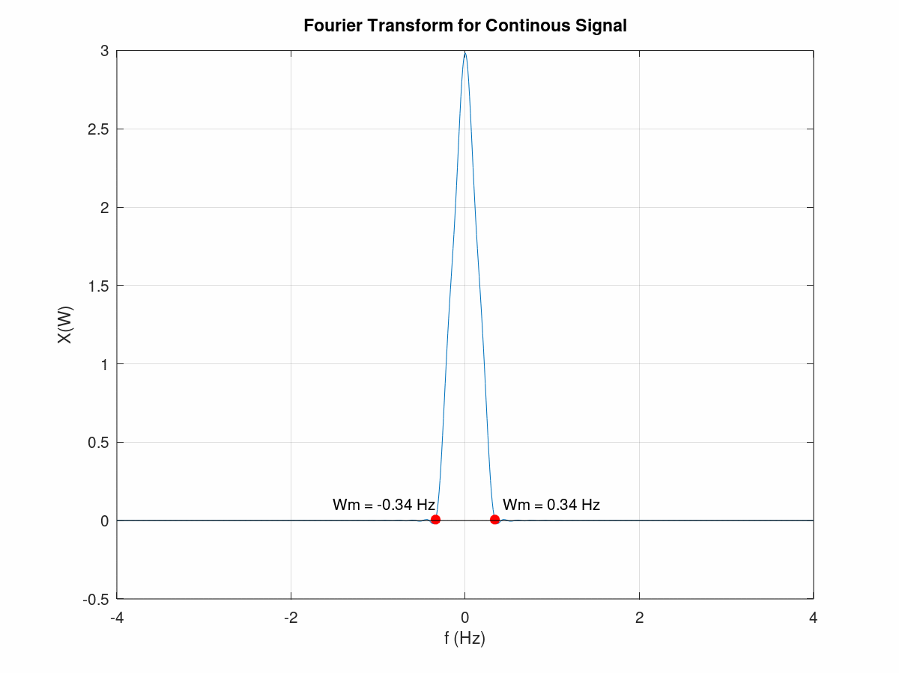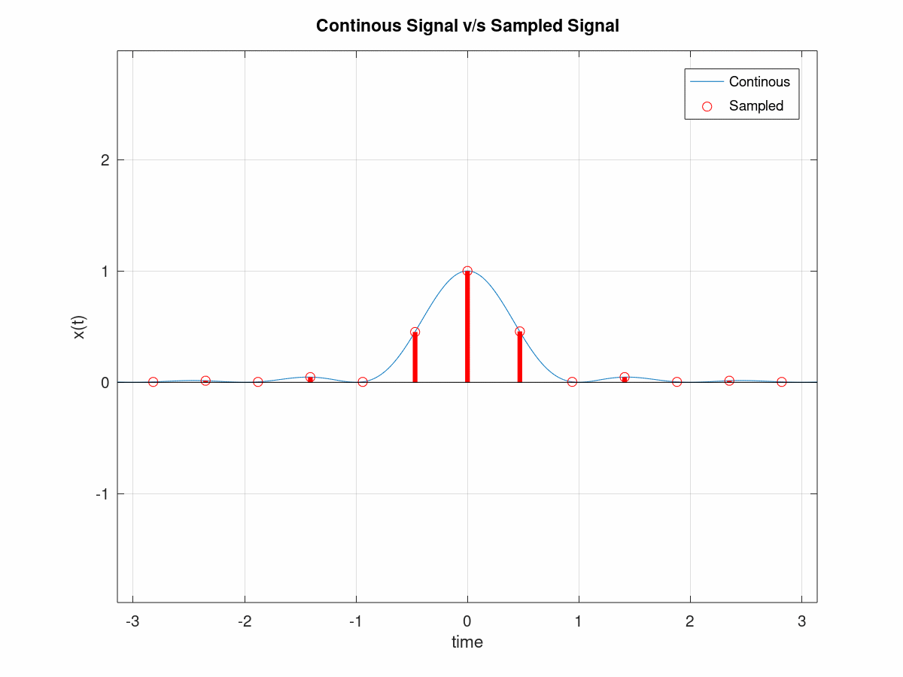

**OUTPUT ( EXTRA WORK / NO GRADING )=-**

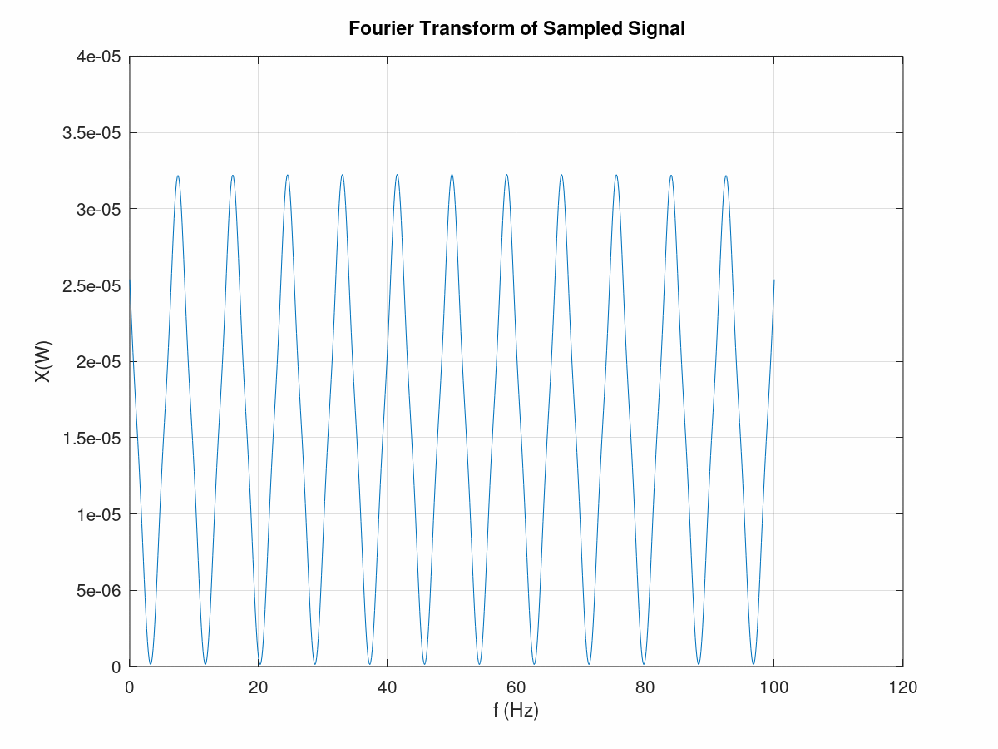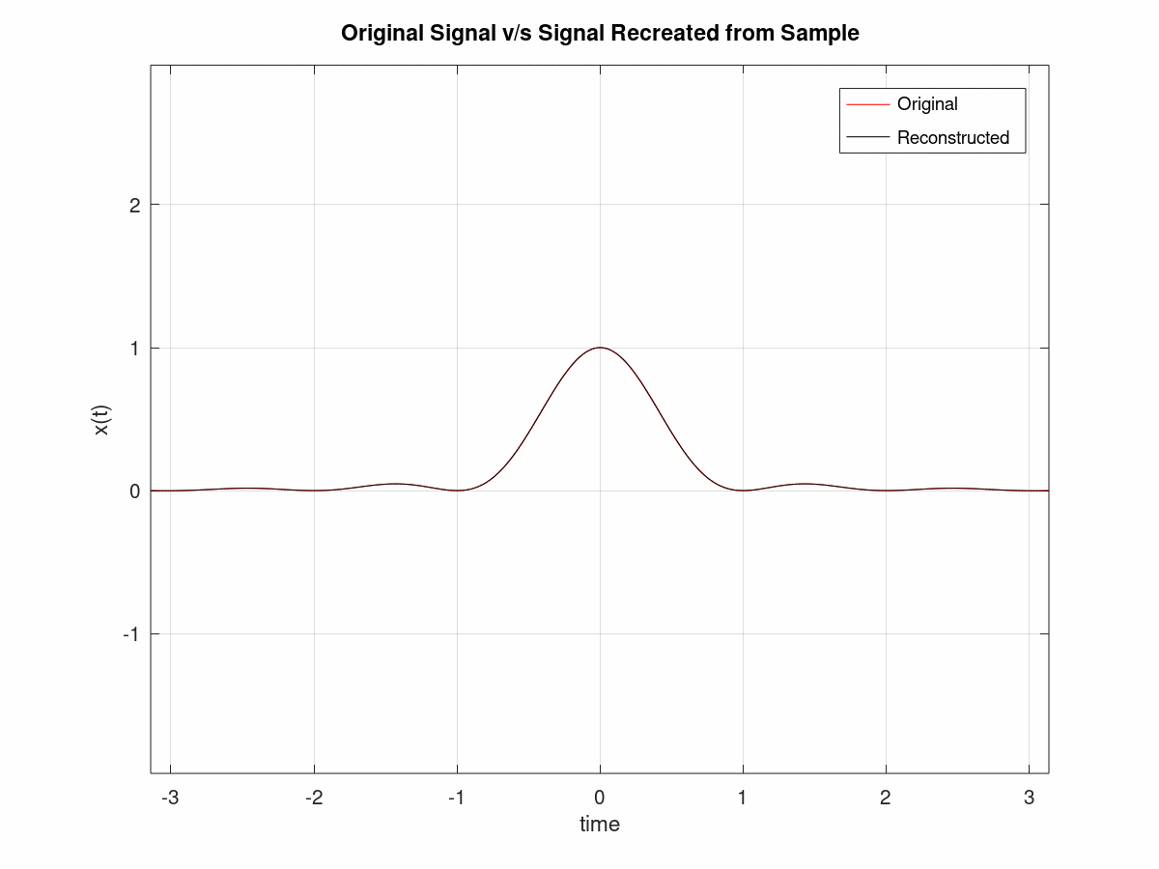

**MATLAB CODE**



close all; clear;

t = -1:0.01:1;

x = zeros(size(t));

x(t >= -1 & t <= 1) = cos(pi*t(t >= -1 & t <= 1));

L = length(t);

f = -4:0.01:4;

X = FT(x, t, 2*pi*f);

mx = abs(max(X)/sqrt(2));

% mx1 = min(find(X(f > 0) < mx)) + length(find(X(f <= 0)));

mx1 = max(find(X(f > 0) >= mx)) + length(find(X(f <= 0))) + 1;

mx2 = min(find(X(f <= 0) >= mx)) - 1;

% Plotting the FFT

figure;

plot(f,X);

hold on;

stem([f(mx1), f(mx2)], [X(mx1), X(mx2)], 'r', 'filled');

title('Fourier Transform for Continous Signal'); xlabel('f (Hz)'); ylabel('X(W)');

grid;

mTxt = sprintf(' Wm = %.2f Hz',f(mx1));

text(f(mx1), X(mx1), mTxt);

mTxt = sprintf(' Wm = %.2f Hz',f(mx2));

text(f(mx2), X(mx2), mTxt, 'HorizontalAlignment', 'right');

Nr = 2*(f(mx1));

sprintf('Nyquist Rate is %.2f Hz.', Nr)

% SAMPLING SIGNAL

s_rate = round(((1/Nr)/(t(2)-t(1))))*(t(2)-t(1));

sample_time = t(1) : s_rate : t(end);

sample_signal = zeros(size(t));

it = 1;

for tt = sample_time

sample_signal(abs(t - tt) < (t(2)-t(1))/2) = x(abs(t - tt) < (t(2)-t(1))/2);

x2(it) = x(abs(t - tt) < (t(2)-t(1))/2);

it = it + 1;

end

% PLOTTING THE SAMPLED SIGNAL

figure;

plot(t,x);

hold on;

stem(sample_time, x2, 'ro', 'LineWidth', 3);

title('Continous Signal v/s Sampled Signal'); xlabel('time'); ylabel('x(t)');

grid; axis equal;

legend('Continous','Sampled');

% FOURIER TRANSFORM OF SAMPLED SIGNAL

X = fft(sample_signal);

X = X/L;

L = length(X);

X(1:end) = 2*X(1:end);

f2 = linspace(0,L,round(L))/L/(t(2) - t(1));

figure;

plot(f2,X);

title('Fourier Transform of Sampled Signal'); xlabel('f (Hz)'); ylabel('X(W)');

grid;

% Recovering Signal

Ts = sample_time(2)- sample_time(1);

Tr = t(2) - t(1);

xr = zeros(size(t));

xr2 = zeros(size(t));

for it = 1:length(t)

xr2(it) = xr2(it) + x2*sinc((t(it) - sample_time)/Ts)';

for ip = 1:length(sample_time)

xr(it) = xr(it) + x2(ip) * sinc(((it-1)*Tr - (ip-1)*Ts)/Ts);

end

end

% PLOTTING THE RECOVERED SIGNAL

figure;

plot(t,x, 'r');

hold on;

plot(t, xr2, 'k');

title('Original Signal v/s Signal Recreated from Sample'); xlabel('time'); ylabel('x(t)');

grid; axis equal;

legend('Original','Reconstructed');

plot(t, xr2, 'k');

title('Original Signal v/s Signal Recreated from Sample'); xlabel('time'); ylabel('x(t)');

grid; axis equal;

legend('Original','Reconstructed');

**OUTPUT**

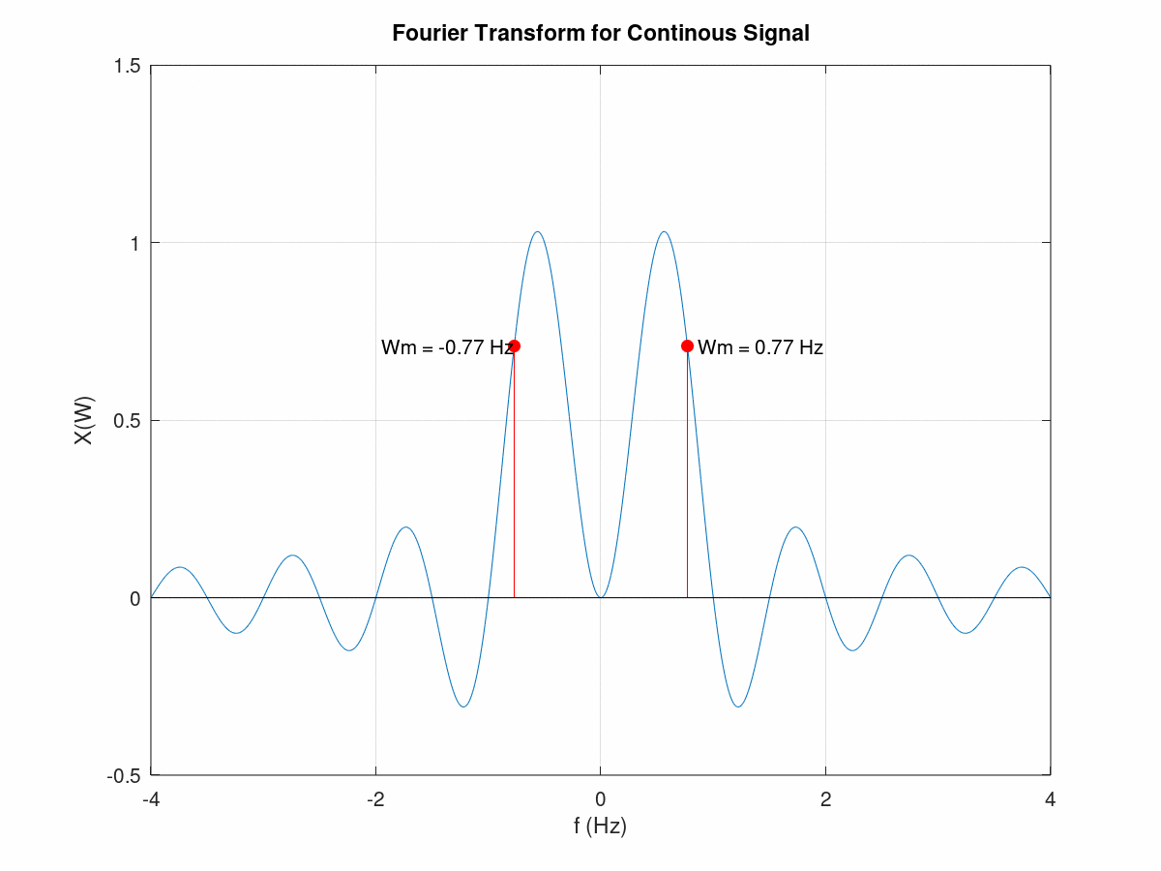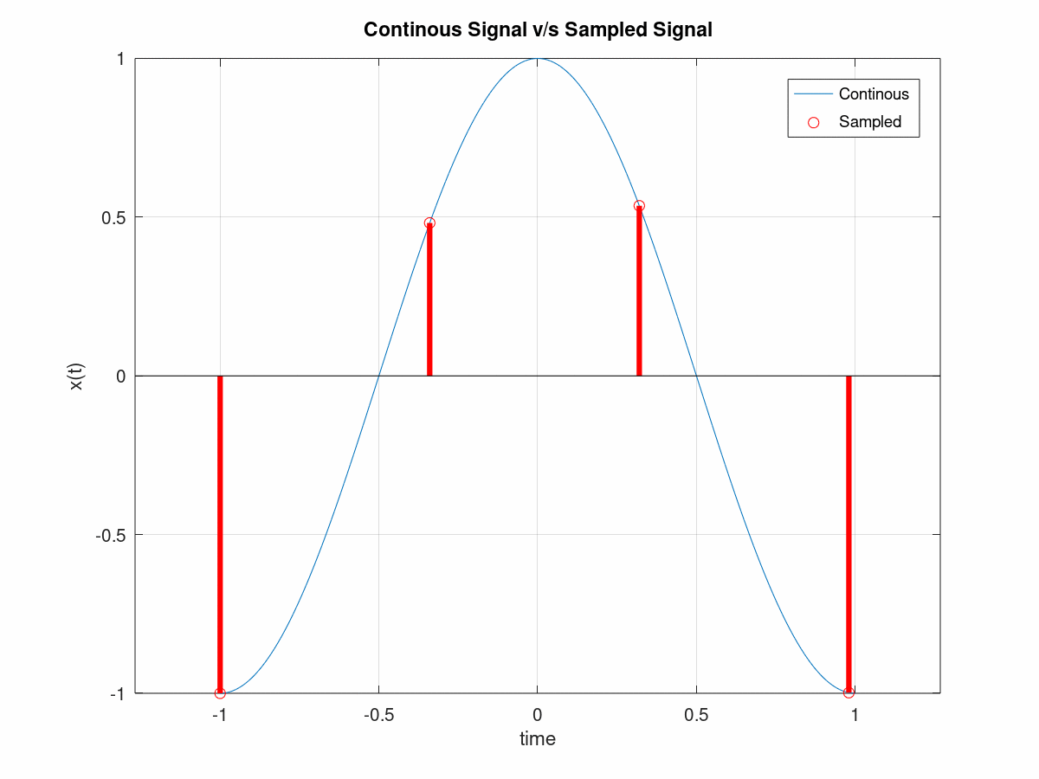

**OUTPUT ( EXTRA WORK / NO GRADING )=-**

